Injured Worker’s First Fill Prescription Form
Administered by CorVel (800) 563-8438

Injured Worker’s Name:
SS#: |  |  | Date of Injury:

Injured Worker Instructions:
On your first Pharmacy visit, please give this notice to any pharmacy listed on this insert to expedite the processing of your approved Workers’ Compensation prescriptions, based on the parameters established by CHUBB. With the CorVel pharmacy program, you do not need to complete any paperwork or claim forms. Simply present this CorVel First Fill Prescription Information Sheet to the pharmacy. You should not incur any costs or co-pays at the pharmacy and you will be allowed up to a 7 or 14 day supply of medications.

Pharmacist Instructions:
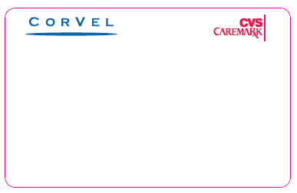
Please use the BIN, PCN, and RxGroup number below to process an online/electronic claim to CorVel:

BIN: 004336
PCN: ADV
RxGroup: RXFFWC695
Member ID: See below to generate ID

To Generate Member ID: The Injured Worker’s nine digit Social Security Number plus 8 digit Date of Injury will be used as their 17 digit Member Identification number when processing their First Fill Prescription: XXXXXXXXXMMDDYYYY

***Please contact CorVel Pharmacy Solutions at (800) 563-8438 for assistance with claims processing***

There are over 72,000 Participating Pharmacies in the CorVel Network. Below is a sample listing. Call (800)563-8438 to locate a Pharmacy near you.

CostCo Pharmacy | H.E.B. Pharmacies | Meijer Pharmacy | Smith’s Food & Drug Centers
CVS | Hy-Vee Pharmacy | Publix Pharmacy | Target Pharmacy
Dominick’s Finer Foods | Ingles Pharmacy | Raley’s Drug Center | Von’s Pharmacy
Drug Mart | Kroger Pharmacy | Rite Aid Pharmacy | Wal-Mart Pharmacy
Fred’s Pharmacy | Longs Drug Store | Safeway Pharmacy | Walgreens Pharmacy
Giant Eagle Pharmacy | Marc’s Pharmacy | Sav-On Drug Store | Wegman Pharmacy
Giant Food Stores, LLC | Medicine Shoppe | Shoprite Supermarkets | Winn Dixie Pharmacy

