
Group Basic & Voluntary Accidental Death & Dismemberment Insurance
For Monthly Paid Policy
Administration Guide

Policy Number:
CI/CO
Underwritten by:
CHUBB Life Insurance
Effective Date:
dd/mm/yyyy

Critical Illness Program

For the employees of:
ABC Company

Introduction
When you choose Chubb Life, you get more than an insurance policy. Our customized solutions, excellent service and an expert team of industry professionals come together to deliver on your insurance need.

Simply put: This is what it means to be Chubb Insured.

This guide provides you with general direction on the following processes:

- Premium Remittance
- Waiver of Premium
- Continuance of Coverage
- Conversion of Coverage
- How to Claim

Keep it handy for future use and to share with new plan administrators when they join your team!

Chubb Life Important Contacts

Premium Remittance | CanadaLifeAccounting@chubb.com
Conversion of Coverage | Canada.ChubbLife@Chubb.com
Claims | Claims.a_h@chubb.com  P: 1-877-772-7797  F: 416-368-0641

Premium Remittance
About Your Basic & Voluntary AD&D Premium Remittance

Your Basic & Voluntary AD&D insurance is self-administered, meaning that you, as the plan administrator are responsible for calculating and remitting your premium to us each month. We do not issue a monthly invoice.

Premiums are due monthly in advance on the 1st of each month.

Your policy has a 31 day grace period, where we will not lapse your coverage within that period, if your premium is late.

We have provided you with a premium reporting form that has the premium rates per $1000 pre-populated for your group’s plan. This form will be required with each premium payment made.

How To Report Your Monthly Basic AD&D Premium

It is important that you remember to provide us with the premium reporting form every time you submit a premium and ensure the following information is updated:

- Full policyholder name and number
- Change the month to accurately reflect the premium payment being made
- If divisions changed or added please note this clearly
- Volume of insurance and # of lives updated
- Note premium by residency of employees (see example below)

If you have employees in ON/QC/MB the volumes must be completed in the proper column to ensure the applicable tax is included. Tax rate formulas have been included for you.

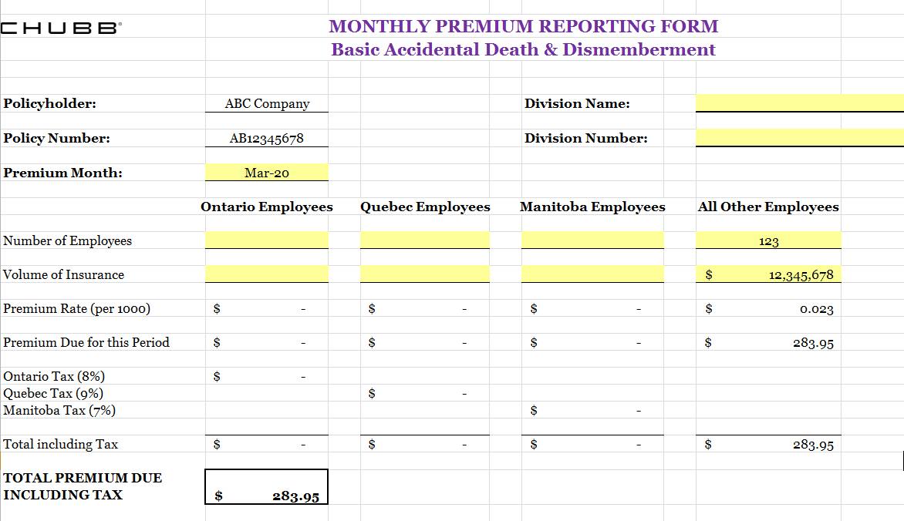

How to Calculate Your Monthly Premium Payment:

Premium is calculated by taking your volume of insurance, dividing it by 1,000 then multiplying it by your Basic AD&D monthly rate per thousand. To illustrate using the example above:

$12,345,678 (total volume of insurance)/1,000 x $0.023 (illustrative rate per thousand) = $283.95
How To Report Your Monthly Voluntary AD&D Premium

On the premium reporting form provided to you, there are 2 tabs; the 1st for your Basic AD&D premium and the 2nd for your Voluntary AD&D premium.

You follow the same process for your Voluntary AD&D premium as you did for your Basic AD&D premium. Remember to complete both tabs and remit your payment for the combined Total Premium Due.

Additional Information About Calculating Volume of Insurance:

Premiums are calculated for complete months only (no pro-rating for partial month).

Effective date of an employee’s coverage is:

- on the 1st of the month, premiums are payable for that month
- after the 1st of the month, premiums are not payable until the next month

For example:

- Coverage is effective on January 1 premiums are payable as of January 1
- Coverage is effective on January 2, premiums are payable as of February 1

Termination date of an employee’s coverage is:

- premiums are payable for the last month of an employee’s coverage

For example:

- Coverage is terminated on January 1, premiums are payable up to and including December
- Coverage is terminated on January 2, premiums are payable for the month of January

How To Remit Your Monthly Premium Payment

You may submit your premium payment to Chubb via Electronic Funds Transfer (EFT) or cheque.

Payment received by EFT is the most efficient and timely method of ensuring your account is updated promptly.

NOTE: We do not accept Interac e-Transfer payments.

How to Pay by EFT/wire:

On the same day that you send your EFT/wire* email a copy of your completed premium reporting form to our finance area at: CanadaLifeAccounting@chubb.com.

It is very important that the EFT clearly indicates your policyholder name & number as a memo, in order that our team can align your payment with your reporting form back-up and appropriately allocate the funds to your account.

*bank account details for wire payments are included on your premium reporting form.

How to Pay by Cheque:

Mail your cheque and completed premium reporting form (retain a copy for your records) to:

Chubb Life Insurance Company of Canada
PO Box 9384, STN A
Toronto, ON M5W 3M2
Lockbox Number: T09384C

It is very important that both your cheque and the premium reporting form reference your policy number.

Waiver of Premium
The policy contains a waiver of premium provision for employees under age 65 should they become totally disabled. Waiver of Premium claims under this policy are automatic and do not require prior approval.

What To Do
We will accept proof of waiver under the group life plan or proof of approval for LTD benefits in order to activate the wavier of premium provision under your Chubb Life Basic AD&D.

Once the waiver of premium is approved by your company’s group life plan, or the employee has been approved for LTD under your company’s disability insurer, waiver is automatic under our policy.

You do not need to send us the notice of waiver, keep the approvals on file for your documentation. If a claim for AD&D benefits is submitted, we will request this information from you as part of the plan administrator’s claims documentation. IMPORTANT! Ensure you adjust the volume on your monthly premium remittance form accordingly when employees go on and off waiver.

Coverage During Waiver of Premium
While premiums are being waived, insurance for that employee will continue to be in force. The benefit amounts will be the amount that was in effect on the date of commencement of total disability. Age reductions and termination under the Chubb policy still apply.

Termination of Waiver of Premium
Waiver of premium for an insured ceases on the earliest of the following date:

- they cease to be totally disabled or no longer on LTD or covered for waiver under the group life plan;
- they do not supply the appropriate evidence deemed necessary to continue waiver of premium (applicable if your company has no group life or LTD and Chubb is approving waiver solely in accordance with the Basic AD&D);
- they turn 65;
- the Policy terminates; or
- they die.
Continuance of Coverage
When an Insured is either; a) laid-off on a temporary basis, b) temporarily absent from work due to short-term disability, or c) on leave of absence, coverage is extended for a period of 12 months following the beginning of such leave, subject to payment of premiums.

When an Insured is on maternity or paternity leave, coverage is extended for a period of up to 18 months following the beginning of the leave, subject to payment of premiums.

Providing the continuance is within the above parameters there is no need to notify Chubb Life.

Conversion of Coverage
Insureds who are under age 70 and terminating their employment with the Policyholder are permitted to convert their Chubb AD&D coverage to an individual policy. Coverage under the individual policy terminates at age 75.

Please advise employees who wish to convert their coverage to email us at: Canada.ChubbLife@Chubb.com and include the group policy number in the subject line.

The appropriate information will then be provided directly to the employee by Chubb Life; there is nothing further the Plan Administrator needs to do.

How To Claim
Contact Chubb Life for all claim submissions, following the guidelines below. Claims are not payable for any period in which premium has not been paid.

Notification of Claim

Claim forms can be requested by the Plan Administrator by contacting the Chubb Life Claims Department as follows:

English: 1-877-772-7797
French: 1-877-337-9494
Email: claims.a_h@chubb.com

Mail: Chubb Life Insurance Company of Canada
Claims Department
2500 - 199 Bay Street
P.O. Box 139, Commerce Court Postal Station
Toronto, Ontario M5L 1E2

If the notification of claim is provided by the insured person, we will provide them with all the required claim forms to be completed, including the Employer/Administrator Statement. In accordance with privacy regulations it is the insured person’s responsibility to forward the Employer/Administrator Statement to the appropriate person at your company for completion.

When contacting the Chubb Life Claims Department, ensure to have the following information ready:
- Policyholder name
- Policy #
- Name of the primary Insured (if claim is being made for a spouse or dependent child).

A claims representative will arrange to forward the standard required forms and advise of any additional information necessary to include when returning the completed forms.

Standard required forms that begin any claim submission:
- Claimant’s Statement – to be completed by the Claimant
- Authorization to Obtain Information – to be completed by the Claimant
- Employer/Administrator Statement – to be completed by the Plan Administrator
- Attending Physician’s Statement – to be completed by the Attending Physician at death or the coroner
- Attending Physician’s Statement – to be completed by the Attending Physician along with supporting medical documentation confirmation the loss

Additional documentation we require:

- Copy of Enrollment Form/Application for Insurance and any Beneficiary Designation/Change Forms
- Copy of the Death Certificate
- Reports (i.e. Coroner’s Report, Autopsy Report, Police Report, Newspaper Articles)

Additional requirements may be needed based on the circumstances of the loss and the beneficiary (e.g. estate, minor beneficiary).

Claim Status Confirmation

Our standard process is to have the initial claim assessment completed within 10 business days of receiving the initial claim documentation. At this time we determine if the claim requires additional information or if a claim decision can be rendered.

If additional documentation is required we request it from the appropriate party. Once a decision is rendered the appropriate letter is sent to the applicable party (i.e. insured person, beneficiary, Estate Representative and Administrator).

If a claim is deemed ineligible, the reason for the coverage determination and appeal process will be provided. Should the insured person, beneficiary or Estate Representative wish to pursue an appeal, Chubb Life recommends that written notice along with supporting documentation is provided within 31 days of the date shown on the original coverage determination letter. We will review the documentation and provide a written response to the insured person, beneficiary or Estate Representative within 10 business days.

Claims Frequently Asked Questions

You will find additional information and answers to frequently asked questions about Accidental Death & Dismemberment claims in the PDF provided separately, “FAQs for AD&D”.

Chubb Life is part of the Chubb group of insurance companies, with operations in 54 countries; Chubb provides commercial and personal property and casualty insurance, personal accident and supplemental health insurance, reinsurance and life insurance to a diverse group of clients.

Chubb Limited, the parent company of Chubb Life, is listed on the New York Stock Exchange (NYSE: CB) and is a component of the S&P 500 index.


